Welcome to a new and exciting year of science, learning, and fun. This year we will be exploring the worlds of biology and physics. During this class you will experience a broad range of topics dealing with biology and physical science. While you will be having fun, you will also be learning and using technology in as a tool to complete many of the class assignments. In additional to the books listed in your syllabus, you will be required to bring the following items to class any day that we are meeting in the lab:
5th Grade Science
- Pencil

- Paper
- Calculator
- Ruler
Technology tools we will use this year:
Microscopes | Educational Websites
Digital Cameras | Excel Spreadsheets
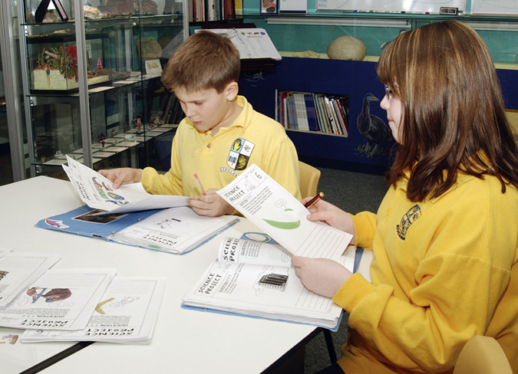
I love Science!
Join the Science Club!

